10/9/2023

**CONTOSO DW**

**DATA INTRODUCTION**

Mahrukh

**Data Analytics**

The dataset consists of several tables, such as accounts, dates, financial strategy plans, product categories, and scenarios. These tables provide a rich source of data for financial and business analysis. The accounts table contains information about different financial accounts, while the date table enables time-based analysis. The strategy plan table contains financial metrics, and product categories and scenarios add further dimensions to the dataset. This dataset is valuable for conducting various financial analyses, including budgeting, forecasting, and performance evaluation.

**DATA CLEANING**

* Deleted the Null values of **CustomerMembers** and the **Account Type** columns from DimAccount.
* Replace +, - with debit and credit respectively from **Operators column**.
* Deleted duplicate column **Value Type, Month name, Week number** and **Year.**
* Deleted column **End date** because it has nullvalues.
* Deleted Null values of **Parent Entity key** and **Parent Entity Label**.
* Deleted duplicate column **Entity Description**.
* Deleted extra row from **DimProduct Category**.
* Deleted duplicate column **Product Category Label** & **Product Category description.**

Cleaned the whole data from Transform Data in Power Bi.

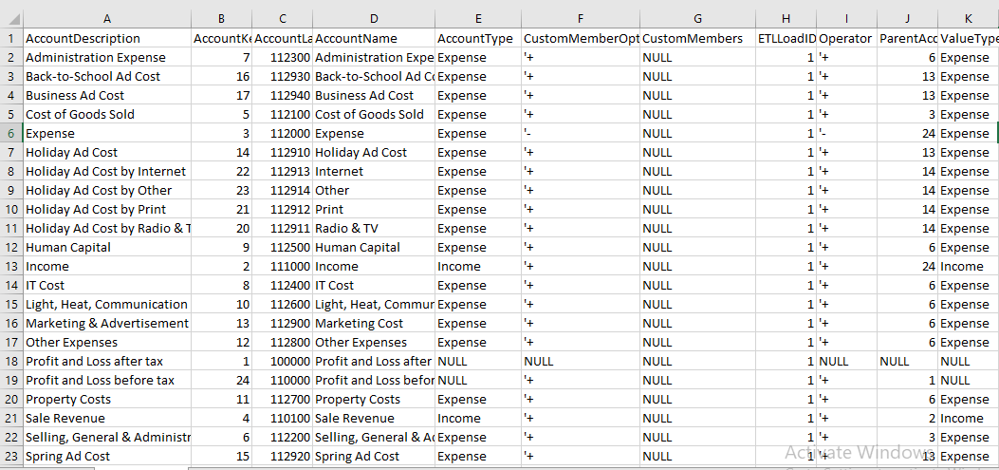

**Data Before Cleaning**

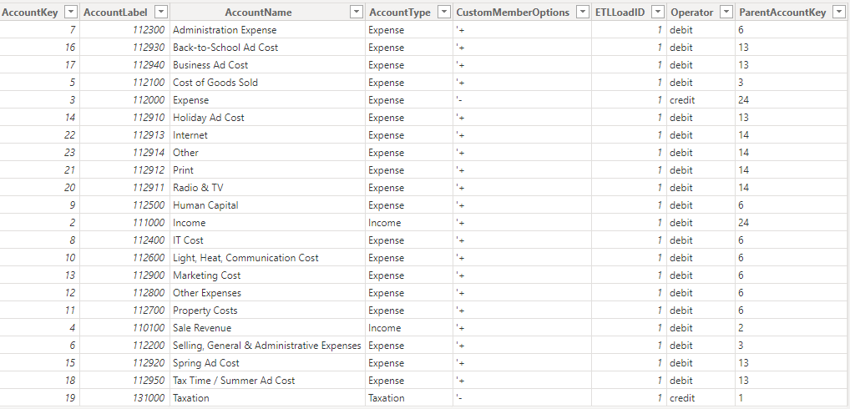

**Data after Cleaning**

**Visualization & Insight**

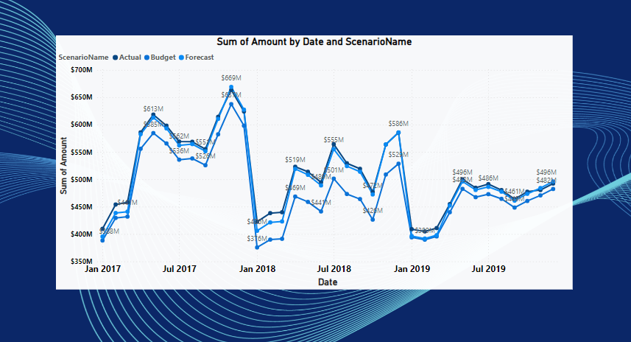

The key takeaway is that on November 1, 2017, the actual financial performance reached its peak at $663 million, surpassing both the budgeted amount of $637 million and the forecasted amount of $669 million. This indicates a positive deviation from the budget and a close alignment with the forecast, suggesting effective financial management and forecasting practices.

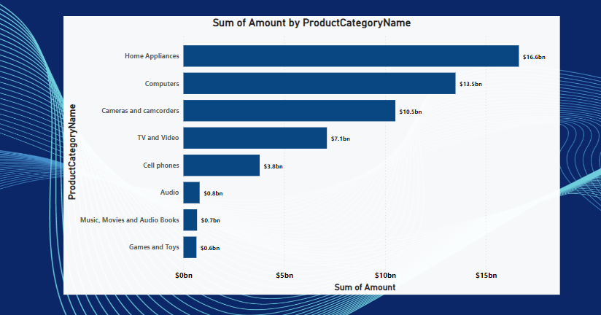

Home Appliances" emerges as the dominant revenue-generating product category, with a substantial contribution of 16.6 billion. This category significantly influences the company's total revenue.

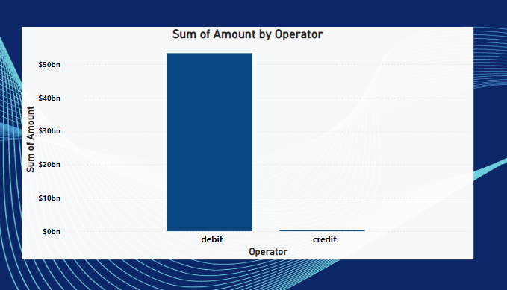

The majority of transactions fall under the "debit" category, with a total value of approximately 53 billion. In contrast, the "credit" transactions appear to be relatively small, indicating that the company has significantly more debit transactions in its financial records.

This insight suggests that further analysis may be needed to understand the reasons behind the predominance of debit transactions and the impact on the company's financial performance.

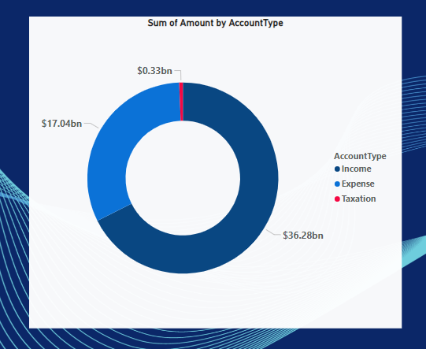

This chart effectively represents the distribution of financial transactions across different account types, highlighting the substantial income and expense amounts, as well as the comparatively smaller taxation expenses. The fact that "Income" has a significantly higher sum of amounts compared to "Expense" and "Taxation" suggests that the company's primary source of revenue or income is substantial. This can be seen as a positive indicator for the company's financial health and profitability.

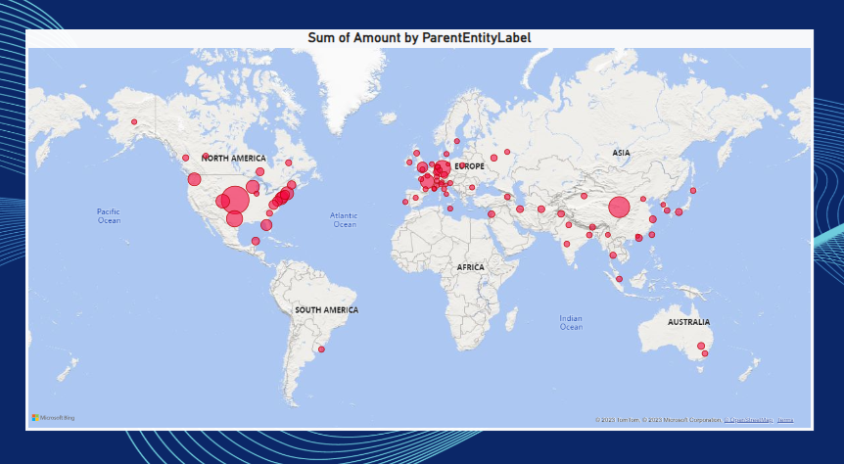

The fact that Europe and North America have more and larger bubbles on the map likely indicates that these regions contribute significantly to the company's revenue. This insight can help the company focus its resources and strategies on these regions to maximize profitability.

**Potential Stakeholder**

Each graph can provide advantages to stakeholders:

1. Date vs. Sum of Amount with Legend for Scenarios: This graph offers top management a clear overview of financial performance trends over time, including actual, budget, and forecast figures. Stakeholders can quickly identify periods of strong or weak performance, enabling timely interventions and strategic planning to achieve financial goals.

2. Product Category vs. Sum of Amount: By visualizing revenue generated by product categories, stakeholders can pinpoint which categories contribute the most to the company's income. This insight helps in optimizing product offerings, marketing strategies, and inventory management to maximize profitability.

3. Operator vs. Sum of AmountThe graph provides a straightforward representation of financial transactions categorized as "debit" or "credit." Top management can identify the dominance of debit transactions, signifying revenue generation, while minimal credit transactions suggest financial stability.

4. Account Type vs. Sum of Amount: This chart highlights the distribution of income, expenses, and taxation. Stakeholders can easily discern that income accounts for the largest share of the company's financial activity. This information guides resource allocation, tax planning, and financial strategy.

5. Parent Entity Label vs. Sum of Amount: Regional performance is visually depicted, with bubble size representing revenue generation. Stakeholders can quickly spot regions with the highest income and identify areas for potential expansion or market focus.